Lab # 12
TRAINING NEURAL NETWORK TO CLASSIFY TWO CLUSTERS IN 2-DIMENTIONAL SPACE
Objective:
- To understand the concept of clustering and classification
- Implementing a neural Network to classify two clusters in 2D space
Lab Related Theory:
Neural Networks:
Neural networks are a set of algorithms, modeled loosely after the human brain, that are designed to recognize patterns. They interpret sensory data through a kind of machine perception, labeling or clustering raw input. The patterns they recognize are numerical, contained in vectors, into which all real-world data, be it images, sound, text or time series, must be translated.
Neural networks help us cluster and classify. You can think of them as a clustering and classification layer on top of data you store and manage. They help to group unlabeled data according to similarities among the example inputs, and they classify data when they have a labeled dataset to train on. (To be more precise, neural networks extract features that are fed to other algorithms for clustering and classification; so you can think of deep neural networks as components of larger machine-learning applications involving algorithms for reinforcement learning, classification and regression.)
A FEW EXAMPLES
Deep learning maps inputs to outputs. It finds correlations. It is known as a “universal approximate”, because it can learn to approximate the function f(x) = y between any input x and any output y, assuming they are related through correlation or causation at all. In the process of learning, a neural network finds the right f, or the correct manner of transforming x into y, whether that be f(x) = 3x + 12 or f(x) = 9x - 0.1. Here are a few examples of what deep learning can do.
CLASSIFICATION
All classification tasks depend upon labeled datasets; that is, humans must transfer their knowledge to the dataset in order for a neural to learn the correlation between labels and data. This is known as supervised learning.
- Detect faces, identify people in images, recognize facial expressions (angry, joyful)
- Identify objects in images (stop signs, pedestrians, lane markers…)
- Recognize gestures in video
- Detect voices, identify speakers, transcribe speech to text, recognize sentiment in voices
- Classify text as spam (in emails), or fraudulent (in insurance claims); recognize sentiment in text (customer feedback)
Any labels that humans can generate, any outcomes you care about and which correlate to data, can be used to train a neural network.
CLUSTERING
Clustering or grouping is the detection of similarities. Deep learning does not require labels to detect similarities. Learning without labels is called unsupervised learning. Unlabeled data is the majority of data in the world. One law of machine learning is: the more data an algorithm can train on, the more accurate it will be. Therefore, unsupervised learning has the potential to produce highly accurate models.
- Search: Comparing documents, images or sounds to surface similar items.
- Anomaly detection: The flipside of detecting similarities is detecting anomalies, or unusual behavior. In many cases, unusual behavior correlates highly with things you want to detect and prevent, such as fraud.
Line Separation
In the following program, we train a neural network to classify two clusters in a 2-dimensional space. We show this in the following diagram with the two classes class1 and class2. We will create those points randomly with the help of a line, the points of class2 will be above the line and the points of class1 will be below the line.

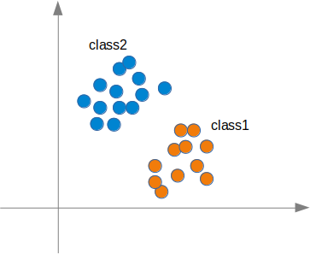

Two clusters of 2-dimensional points
We will see that the neural network will find a line that separates the two classes. This line should not be mistaken for the line, which we used to create the points.
This line is called a decision boundary.

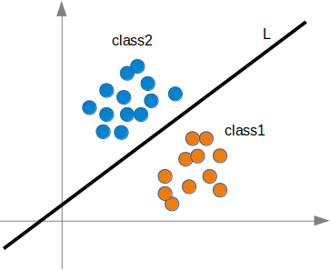

References:
- https://www.python-course.eu/neural_networks.php

LAB EXERCISE

Q1. Write and Understand code to implement Artificial Neural Network in Python to classify two clusters in 2D space (refer to the code provided to you)
Learning Outcomes:
In this Lab Implementing a neural Network to classify two clusters in 2D space

